Result Screen Captures
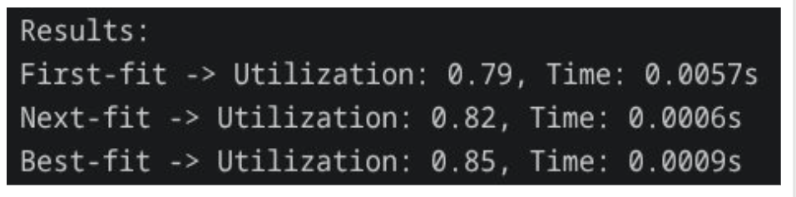
Figure 1. Result of Memory Allocation Strategies

This figure shows the performance comparison of three memory allocation strategies: First-Fit, Next-Fit, and Best-Fit. The results highlight both memory utilization and execution time for each method. Best-Fit achieves the highest memory utilization (0.85), indicating more efficient use of memory, while Next-Fit has the fastest execution time (0.0006s), making it the quickest strategy. First-Fit provides a balance between the two, with moderate utilization (0.79) and execution time (0.0057s).

